

Services Management System For

Housing Society

**By**

**Muhammad Taha Amin**

(BSCS/F14/0117)

**Muhammad Areeb Vohra**

(BSCS/F14/0112)

**Syed Abdul Moiz Hussain**

(BSCS/F14/0128)

2018

**Faculty of Engineering Sciences and Technology**

Hamdard Institute of Engineering and Technology

Hamdard University, Karachi, Pakistan



Services Management System For

Housing Society

**By**

**Muhammad Taha Amin**

(BSCS/F14/0117)

**Muhammad Areeb Vohra**

(BSCS/F14/0112)

**Syed Abdul Moiz Hussain**

(BSCS/F14/0128)

Under the supervision of

**Prof. Adnan Ahmed Siddiqui**

*(Assistant Professor)*

2018

**Faculty of Engineering Sciences and Technology**

Hamdard Institute of Engineering and Technology

Hamdard University, Karachi, Pakistan



Services Management System For

Housing Society

**By**

**Muhammad Taha Amin**

(BSCS/F14/0117)

**Muhammad Areeb Vohra**

(BSCS/F14/0112)

**Syed Abdul Moiz Hussain**

(BSCS/F14/0128)

A project presented to the

**Faculty of Engineering Sciences and Technology**

Hamdard Institute of Engineering and Technology

In partial fulfillment of the requirements for the degree

**Bachelors of Science**

**In**

**Computer Science**



**Faculty of Engineering Sciences and Technology**

Hamdard Institute of Engineering and Technology

Hamdard University, Karachi, Pakistan

**CERTIFICATE**

This project “Services Management System” is presented by **Syed Abdul Moiz Hussain, Muhammad Areeb Vohra** and **Muhammad Taha Amin** under the supervision of their project advisors, approved by the project examination committee, and acknowledged by the Hamdard Institute of Engineering and Technology, in the fulfillment of the requirements for the bachelor degree of Computer Science.

|  |  |
| --- | --- |
| **_______________________** | **________________________** |
| Prof Adnan Ahmed Siddiqui | (Member) |
| (Project Supervisor) | Name & Signature |
| _______________________ | ________________________ |
| Mr. Muhammad Fahad | (Member) |
| (Project Co-Supervisor) | Name & Signature |
| **______________________** | ________________________ |
| Prof. Dr. Aqeel ur Rehman | (Member) |
| (Chairman, Department of Computing) | Name & Signature |
| _________________________ |  |
| Acting Director, HIET |  |
| (Prof. Dr. Pervaiz Akhter) |  |

**ACKNOWLEDGEMENT**

All praises and thanks to Al Mighty **“ALLAH**”, the most Merciful, the most Gracious, the source of knowledge and wisdom endowed to mankind, Who conferred us with the power of mind and capability to take this project to the exciting Ocean of knowledge. All respects are for our most beloved Holy Prophet “**Hazrat MUHAMMAD (Peace Be Upon Him)**”, whose personality will always be source of guidance for humanity.

Acknowledgement is due to **Hamdard Institute of Engineering and** **Technology** for support of this Project, a highly appreciated achievement forus in the undergraduate level.

We wish to express our appreciation to our **Supervisor Prof. Adnan Ahmed Siddiqui** who served as our major advisor. We would like toexpress our heartiest gratitude for their keen guidance, sincere help and friendly manner which inspires us to do well in the project and makes it a reality.

Many people, especially our classmates and team members itself, have made valuable comment suggestions on this proposal which gave us an inspiration to improve our project. We thank **Co-Supervisor Muhammad** **Fahad**, our faculty teachers and all the people for their help, directly and indirectly, to complete ourproject.

**ABSTRACT**

This project **Services Management System for Housing Society** is a service you can interact via both Android application and Website to avail and get facilitate with the household services. Although there are a few projects publicly available resembling to this but none of them are made for any specific or particular housing society.

This project provides access to members of the housing society to just request for service in a very easy and productive manner and it also provides workers the opportunity to earn. The workers working for the society can provide multiple services as professionals.

Services Management System provides their customers the impeccable way to request for service and a simple cash on delivery payment method with the 100% customer satisfaction guarantee.

The motivation behind this project was the problems people faces for finding any professional workers. Customers have to find the service men by making phone calls or find one in the hardware shop nearby and the customer has to face the lame excuses of the workers. More over workers are not often available or good enough and also ask for more price that does not contemplate the reasonable prices, so these were the issues we got through and found a solution.

Table of Contents

CHAPTER 1: INTRODUCTION 1

1.1 Motivation 1

1.2 Problem Statement 1

1.3 Aims & Objectives 1

CHAPTER 2: REQUIREMENT SPECIFICATIONS 3

2.1 Literature Review 3

2.1.1 Study of Implementation of Society Management System 3

2.1.2 Ubiquitous Smart Home System Using Android Application 3

2.1.3 Implementation of Society Management System: SOCIETALES 3

2.1.4 Ubiquitous Home Control and Monitoring System Using Internet of Things 4

2.1.5 Implementation of Facility Maintenance Management System using Smart Phones 4

2.2 Project Scope 5

2.3 Big Picture 5

2.4 Usage Scenario 5

2.5 Functional Requirements 6

2.5.1 Admin Panel: 6

2.5.2 User Panel (Web App): 6

2.5.3 User Panel (Android App): 6

2.5.4 Worker Panel (Web App): 6

2.5.5 Worker Panel (Android App): 7

2.6 Non-Functional Requirements 7

2.6.1 Usability 7

2.6.2 Security 7

2.6.3 Performance 7

2.7 Software Quality Attributes 8

2.7.1 Availability 8

2.7.2 Development Platforms 8

Chapter 3: Software Development and Process Model 9

3.2 Team Role & Responsibilities (RACI Matrix) 10

3.3 Requirement Phase 10

3.4 Development Phase 11

3.4.1 Code sample of Connection URLs 11

3.4.2 Code Sample of Retrieving Substrings 12

3.4.3 Code Sample of Handling a Network Error 13

3.4.4 Code Sample of Network Request 14

3.5 Testing Phase 15

3.5.1 Black Box Testing: 15

3.5.2 System Testing 16

3.5.3 Unit Testing 16

3.5.4 Integration Testing 17

3.5.5 Functional Testing 17

3.5.6 User Acceptance Testing 18

3.5.7 Finalized Testing 18

3.6 Test Cases: 19

3.6.1 Test Case # 1 19

3.6.2 Test Case # 2 19

3.6.3 Test Case # 3 20

3.6.4 Test Case # 4 20

3.6.5 Test Case # 5 21

3.6.6 Test Case # 6 21

Chapter 4: Project Planning 23

4.1 First Evaluation Gantt Chart 23

4.3 Website GUI Screenshots 25

4.4 Admin Dashboard GUI 31

4.5 Android Application GUI (for customers) 33

4.6 Mobile Application GUI (for Workers) 38

# CHAPTER 1: INTRODUCTION

This project is for the citizens of a society to be able to hire workers like carpenters, plumbers, electricians, sweepers, line-men etc., without even going out of the residential area they are in. Users can either open website or mobile application to request for a service, define their problem and on submission a worker will be en-route to their location.

The project provides easy and a friendly user interface so that the user has no hurdles in solving their household problems.

## 1.1 Motivation

The proposed project introduces the application which will integrate society’s every problem on a platform, and the problem will be on few clicks away to be solved.

## 1.2 Problem Statement

In housing societies, problems regarding any household issues like electricity, plumbing, gas leakage, carpentry, fumigation, etc. the person himself has to go and bring the repair man, which takes a lot of time and effort.

## 1.3 Aims & Objectives

1. The main objective of this project is to develop a web and application-based software that is used to inform about the problem of the person is having, concerning any household problems like leakage of gas, water seepage, electricity issues, plumber required for wrecked furniture etc.
2. As Android based smart phones have become very popular and common devices for innovations, so we are using this platform as a user interfacing medium.
3. The salient objective to develop a mobile application is for the reduction of complexity in the system and essentially to save people’s time.
4. And definitely a web-based service control manager where all the required services of the users will be entertained and responded.

# 

# CHAPTER 2: REQUIREMENT SPECIFICATIONS

## 2.1 Literature Review

### **2.1.1 Study of Implementation of Society Management System**

The concept of this paper is that to keep the people of a society up to date with their daily activities, by notifying the activities on the application. So majority will go through with every problem or issue, along with, in the societies where people don’t interact with each other much, will be able to strengthen their neighborhood.[1]

### **2.1.2 Ubiquitous Smart Home System Using Android Application**

The paper defines an android based application which uses an Arduino as a server to control the appliances of a home. This can help us in using the methodology to control not any appliances but the complaints of the society, by using internet server/domain instead of Arduino, as a connecting medium.[2]

### **2.1.3 Implementation of Society Management System: SOCIETALES**

The paper focuses on the online posting of the complaints using android applications for any residential society. A society has to deal with many functions like day to day complaints, involving water supply, maintenance of electricity. So to manage and integrate everything on a single platform would help to maintain a well-defined environment within the society. This project is implemented on the housing society but we thought that it should be applied for every single apartment in the society. Every society has different criteria for the maintenance of apartments but we would make this to create a generic application once useable for almost every society management. [3]

### **2.1.4 Ubiquitous Home Control and Monitoring System Using Internet of Things**

This project uses the Internet of Things (IoT) to monitor houses in the society and monitor and control appliances of the house too. It uses wireless network or 3G/4G to connect 8051 microcontrollers as a hosting controller.

A flowchart in this project is used to check the online activity of the user that whether the user is connected or not. [4]

### **2.1.5 Implementation of Facility Maintenance Management System using Smart Phones**

This paper conveys the message that the use of smart phones is increasing gradually and the whole world is in the palm of our hands through high speed internet and cellular internet connectivity, due to which the use of web-based applications on personal computer is decreasing. This paper proposes an integrated android based mobile application and a web-based system that facilitates maintenance management in apartment buildings that saves unnecessary man power that can be used in other aspects.

The methodology of creating an integrated mobile application and web based system is useful to consult the idea of our project. [5]

## 2.2 Project Scope

The proposed project includes a website and an Android application through which user can submit a request for services we have provided which includes electrician for any kind of electronic repairs, carpenter for any furniture damage, fire brigade, ambulance, doctor and plumber for any plumbing issues.

## 2.3 Big Picture

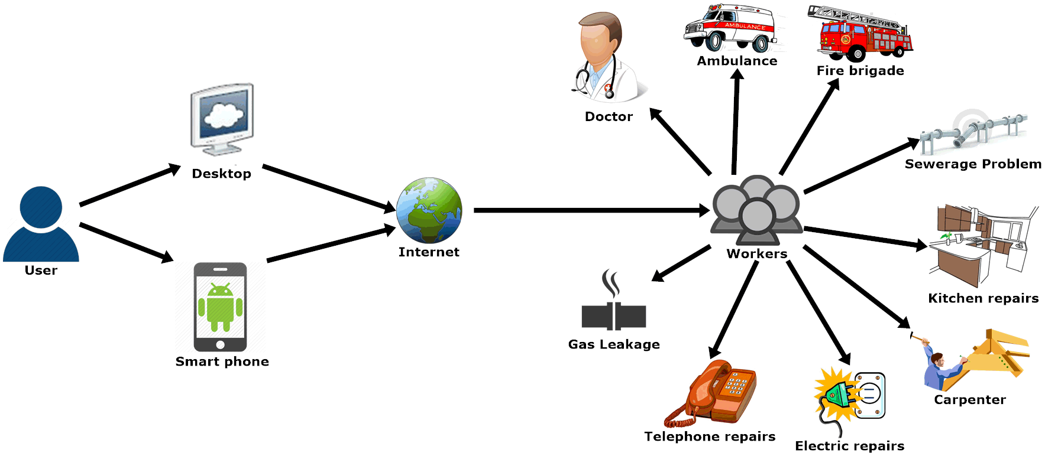

## 2.4 Usage Scenario

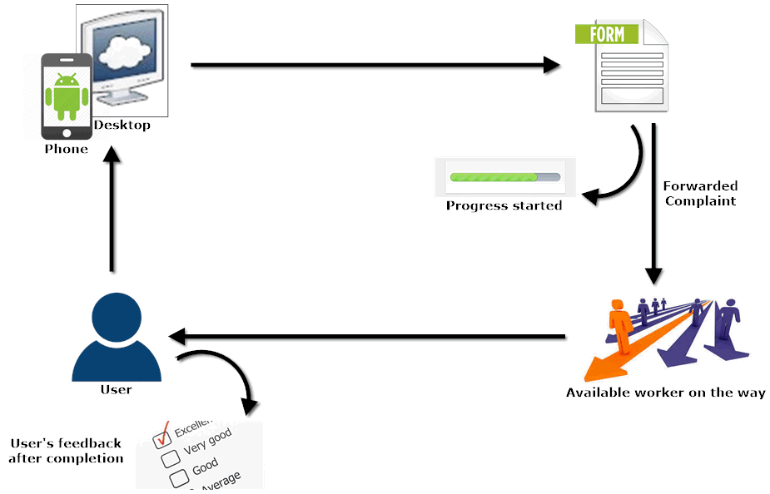

## 2.5 Functional Requirements

The project has a total of five modules, three on the web application side and two modules on the android application side.

Users are able to give ratings and reviews about the workers they hire, and are notified about any new information of the society from the admins.

### 2.5.1 Admin Panel:

Through this panel, administrators are able to register new service providers and monitor their activities, view sales reports and go through any technical issues faced by citizens. The admin can delete any user, worker or modify their roles as per the needs.

### 2.5.2 User Panel (Web App):

This panel allows users to first login to their assigned accounts then search for the service provider of their need, define their problem and get the service at a given time. Users can also check the history of their orders. They can edit their profile name, address, phone etc.

### 2.5.3 User Panel (Android App):

Android application works the same way as the web app, instead the user doesn’t need a desktop or laptop for accessing the web portal. User can also check the history of their submitted orders.

### 2.5.4 Worker Panel (Web App):

Web portal for workers allows them to add the service they want to provide, receive and view order description and modify status, review sales reports, check their commissions and edit their profile.

### 2.5.5 Worker Panel (Android App):

Through the Android application of the worker panel, workers can do all the activities that they are allowed to do on the web application, view order description and modify status etc.

## 2.6 Non-Functional Requirements

### 2.6.1 Usability

1. A friendly Graphical User Interface.
2. An upgradable system, in future if needed.
3. Availability of android and web application.

### 2.6.2 Security

* + 1. Every individual user’s data is only accessible by that user only.
    2. User data will be privacy protected.
    3. Request are required to be submitted by the authorized users only so that spams are avoided for workers.

### 2.6.3 Performance

1. This project is a multiplatform (web/mobile) application.
2. Multiple users can be logged in at a same time, either customers or workers.
3. The application will work only within the premises of the housing society resulting quick response from the network.

## 2.7 Software Quality Attributes

### 2.7.1 Availability

If the internet services gets disrupted while sending information to the server. The information can be send again.

### 2.7.2 Development Platforms

**For Website:**

XAMP v7.2.3

MySQL Database

Apache Web Server

HTML 5, CSS-3

Wordpress v4.9

JWT-Authorization

WooCommerce Multivendor Plugin

WooCommerce REST-API

**For Android:**

Android Studio v3.1.3

Java SE Development Kit 8 update 101

Java 8 update 181

Postman (for REST-API testing)

Insomnia (REST-API testing

**Android Studio Libraries:**

com.squareup.picasso:picasso:2.71828 (for rendering Images)

com.google.code.gson:gson:2.8.0 (for handling JSON parsing)

com.android.volley:volley:1.0.0 (for handling Network Requests)

Chapter 3: Software Development and Process Model3.1 Methodology - Agile:

We have used sprints of agile methodology during the development of web and android apps.

Firstly the web application was developed according to the requirements and improvements were made time to time recommended by the supervisors. In the initial stages the approach was totally using the plugins and layout customization tools to develop the web application, but when we started to implement the functionality we realized that changes in the plugins files and custom coding was required to deliver the functionality defined by the project scope.

Using sprints of agile methodology we were able to revert back to the initial design and make the necessary changes needed, so we could move forward with ease.



## 3.2 Team Role & Responsibilities (RACI Matrix)

**R**esponsibility, **A**ccountability, **C**onsultant, **I**nformed.

|  |  |  |  |  |
| --- | --- | --- | --- | --- |
|  | **Taha Amin** | **Areeb Vohra** | **Abdul Moiz** | **Supervisor/Co-supervisor** |
| **Design** | R | C | A | C,I |
| **Analysis** | R | R | A,C | C,I |
| **Development** | C | R,A | R,C | C,I |
| **Testing** | A | R | A,C | C,I |

## 3.3 Requirement Phase

In the requirement phase we gathered requirements from both literature reviews and the improvements which we studied to be required in ongoing projects in this domain.

The main requirements are as follows:

1. The project is a web/android based application used for by the citizens of a housing society.
2. Admin panel is required to create accounts and specify roles to workers and customers, manage and review order details and check for any queries asked by the users.
3. An android application is required for the workers from which they can view order description, modify status and respond to the request from customers.
4. Users should be able to interact from both web and android application to request any service, view order history and check status of pending orders.

## 3.4 Development Phase

### 3.4.1 Code sample of Connection URLs



**Description:** In the above code sample all the necessary connections between the website and android application are made.

### 3.4.2 Code Sample of Retrieving Substrings

**Description:** In the above code the functions “getStringList()” returns multiple occurrences at specific points of the source string. The specific points are provided by using the arguments, “startOfSearch” and “endOfSearch”.

### 3.4.3 Code Sample of Handling a Network Error

**Description:** The above code responds with the type of error from a Volley network request.

### 3.4.4 Code Sample of Network Requests

**Description:** The above code is used to customize every Volley network request throughout the application. This custom class is also useful for notifying URLs with a Toast message whenever a request is executed.

## 3.5 Testing Phase

We started testing each module of the project as they came into development.

1. Responsiveness of website.
2. Created users validation.
3. Login validation of users and workers.
4. Created services testing.
5. Add to cart and checkout.
6. Billing details.
7. Retrieval of every order through REST-API in android application.
8. Retrieval of images in android app.
9. Status update of orders in web/android synchronously.
10. Forgot password.

### 3.5.1 Black Box Testing:

In software testing, blackbox testing plays a vital role in testing of the system. The procedure of the blackbox testing is to check the performance and ensur that the functionality of the application is working fine. If it’s software testing or user acceptance testing or integration testing, blackbox testing is eligible to be implemented on each level. It can certainly dominate unit testing but surely is not that much of a higher level testing.

This method attempts to find errors in the following categories:

1. Incorrect or missing functions
2. Interface errors
3. Behavior or performance errors
4. Initialization and termination errors

We took all the requirements of this project to test its functionality requirements.

1. Users and workers must have login in portal by using their usernames and passwords.
2. Only Registered users and workers can access the portal.

### 3.5.2 System Testing

System testing is an operation that includes system testing, trainings of users and proper working of the developed system. The person from the user side test the changes developed in the system and checks if the system has changed according to their needs. This testing phase includes the testing of system using different kinds of data. A detailed testing of data is initialized and by the use of the test data, system is tested. The errors are noticed during testing and improvements are made. Training sessions are conducted for the staff so that they can operate the system that is developed. In this phase of testing, the main objective of the testing team is to make sure that the system works precisely and is error-free.

Major types of system testing are:

1. Unit Testing
2. Integration Testing
3. User acceptance Testing
4. Functional Testing

### 3.5.3 Unit Testing

User acceptance testing is the final process of software testing. The users of the software test’s the software during user acceptance test and ensure the system is enabled to handle the tasks required as per the requirements. For the success of any system, user acceptance is the key factor. During the testing, developers remain in contact with the users of the system so if they want to make changes that are required.

### 3.5.4 Integration Testing

In the integration testing phase, modules of the software are joined to perform testing as a group. This phase comes before validation testing and after unit testing. Unit tested modules are taken as an input and are grouped together so that the plans of the integration test plan as planned can be applied to the joint groups, after which when the output is delivered, system testing is prepared to be implemented by the integration system. It probably works as a systematic testing that constructs the structure of a program during the error checking initialized by conducting tests. In this phase correction is impossible because it could cause you time, money and effort.

### 3.5.5 Functional Testing

This phase of testing is a very important phase and is implemented within the software development that helps ensure that the system is working as per the specifications and requirements. Basically, this phase is based on the testing of the functionality that is required and specified by the user and the whole system is check at different peak to test the functionality. Functional testing is kind of a Black Box testing in which requirements of the software parts are put under test which has the bases in test cases. Required inputs are entered and outputs are examined. Functional testing is all about what the system functions.

### 3.5.6 User Acceptance Testing

User acceptance testing is the final process of software testing. The users of the software test’s the software during user acceptance test and ensure the system is enabled to handle the tasks required as per the requirements. For the success of any system, user acceptance is the key factor. During the testing, developers remain in contact with the users of the system so if they want to make changes that are required.

### 3.5.7 Finalized Testing

We encountered bugs and errors that were fixed at the same time. The website/application was tested by creating users, workers, adding demo details and uploading demo services, and generating orders by multiple users requesting for multiple services.

The android application for workers was also tested by responding to generated orders, updating the status, and viewing order details.

## 3.6 Test Cases:

### 3.6.1 Test Case # 1

Testing the account creation for customers on the website in the MY ACCOUNT page

|  |  |
| --- | --- |
| **Preconditions** | Go to the MY ACCOUNTS page and create a new account. |
| **Actions** | Enter Username, Email, and Password and click Register to create your account. |
| **Expected Results** | The system has created a new account for the user. |
| **Tested By** | Muhammad Areeb Vohra and Syed Abdul Moiz Hussain |
| **Result** | Pass |

### 3.6.2 Test Case # 2

Browsing through the website as a customer and requesting for a service

|  |  |
| --- | --- |
| **Preconditions** | Open the SERVICES page and select a worker from the available categories and request a service. |
| **Actions** | Enter time, date, contact details and submit the request. |
| **Expected Results** | The user will receive a complete summery of his/her order. |
| **Tested By** | Muhammad Areeb Vohra and Syed Abdul Moiz Hussain |
| **Result** | Pass |

### 3.6.3 Test Case # 3

Responding to a request from the workers dashboard

|  |  |
| --- | --- |
| **Preconditions** | In the workers dashboard the worker will navigate to the orders tab and view his orders list. |
| **Actions** | Worker will open a received order view the order details, contact the customer, and change status from pending to processing |
| **Expected Results** | After the customer is contacted his status will change from pending to processing |
| **Tested By** | Muhammad Areeb Vohra and Muhammad Taha Amin |
| **Result** | Pass |

### 3.6.4 Test Case # 4

Registering a new worker and adding his services for the customers to view

|  |  |
| --- | --- |
| **Preconditions** | The worker will fill out a form adding his complete details and skills. |
| **Actions** | The admin will receive the form and after analyzing the individuals details admin will create an account for the worker and publish his service. |
| **Expected Results** | The worker can open his new dashboard and his service is published on the website |
| **Tested By** | Muhammad Areeb Vohra and Muhammad Taha Amin |
| **Result** | Pass |

### 3.6.5 Test Case # 5

Requesting for a service on the Customer Mobile Application

|  |  |
| --- | --- |
| **Preconditions** | Open the SERVICES screen and select a worker from the available categories and request a service. |
| **Actions** | Enter time, date, contact details and submit the request. |
| **Expected Results** | The user will receive a complete summery of his/her order. |
| **Tested By** | Muhammad Areeb Vohra and Syed Abdul Moiz Hussain |
| **Result** | Pass |

### 3.6.6 Test Case # 6

Responding to a request from the workers Mobile Application

|  |  |
| --- | --- |
| **Preconditions** | Open my orders from the menu and view order details for the requested service |
| **Actions** | View the order details, contact the customer, and change status from pending to processing |
| **Expected Results** | After the customer is contacted his status will change from pending to processing |
| **Tested By** | Muhammad Areeb Vohra |
| **Result** | Pass |

# Chapter 4: Project Planning

## 4.1 First Evaluation Gantt Chart

|  |  |  |  |
| --- | --- | --- | --- |
| Task Name | Duration | Start | Finish |
| **FYP First Evaluation** | **150 days** | **Tue 8/1/17** | **Wed 1/31/18** |
| **Requirement Analysis** | **40 days** | **Tue 8/1/17** | **Tue 10/10/17** |
| Elicitation of Requirement |  | Tue 8/1/17 | Tue 10/10/17 |
| Analysis of Requirement |  | Tue 8/1/17 | Tue 10/10/17 |
| Requirement Validation |  | Tue 8/1/17 | Tue 10/10/17 |
| **Designing** | **30 days** | **Mon 9/11/17** | **Fri 12/1/17** |
| Web Application Design |  | Wed 9/27/17 | Sun 11/19/17 |
| **Implementation** | **40 days** | **Wed 11/1/17** | **Tue 12/26/17** |
| Web Development |  | Wed 11/1/17 | Tue 12/26/17 |
| **Testing** | **50 days** | **Mon 9/11/17** | **Wed 1/31/18** |
| Black Box Testing |  | Wed 11/1/17 | Wed 1/31/18 |
| White Box Testing |  | Wed 9/27/17 | Wed 1/31/18 |

**Timeline**

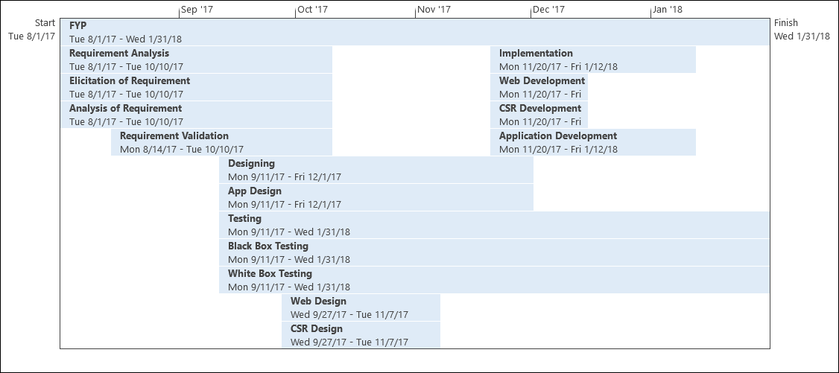

## 4.3 Website GUI Screenshots

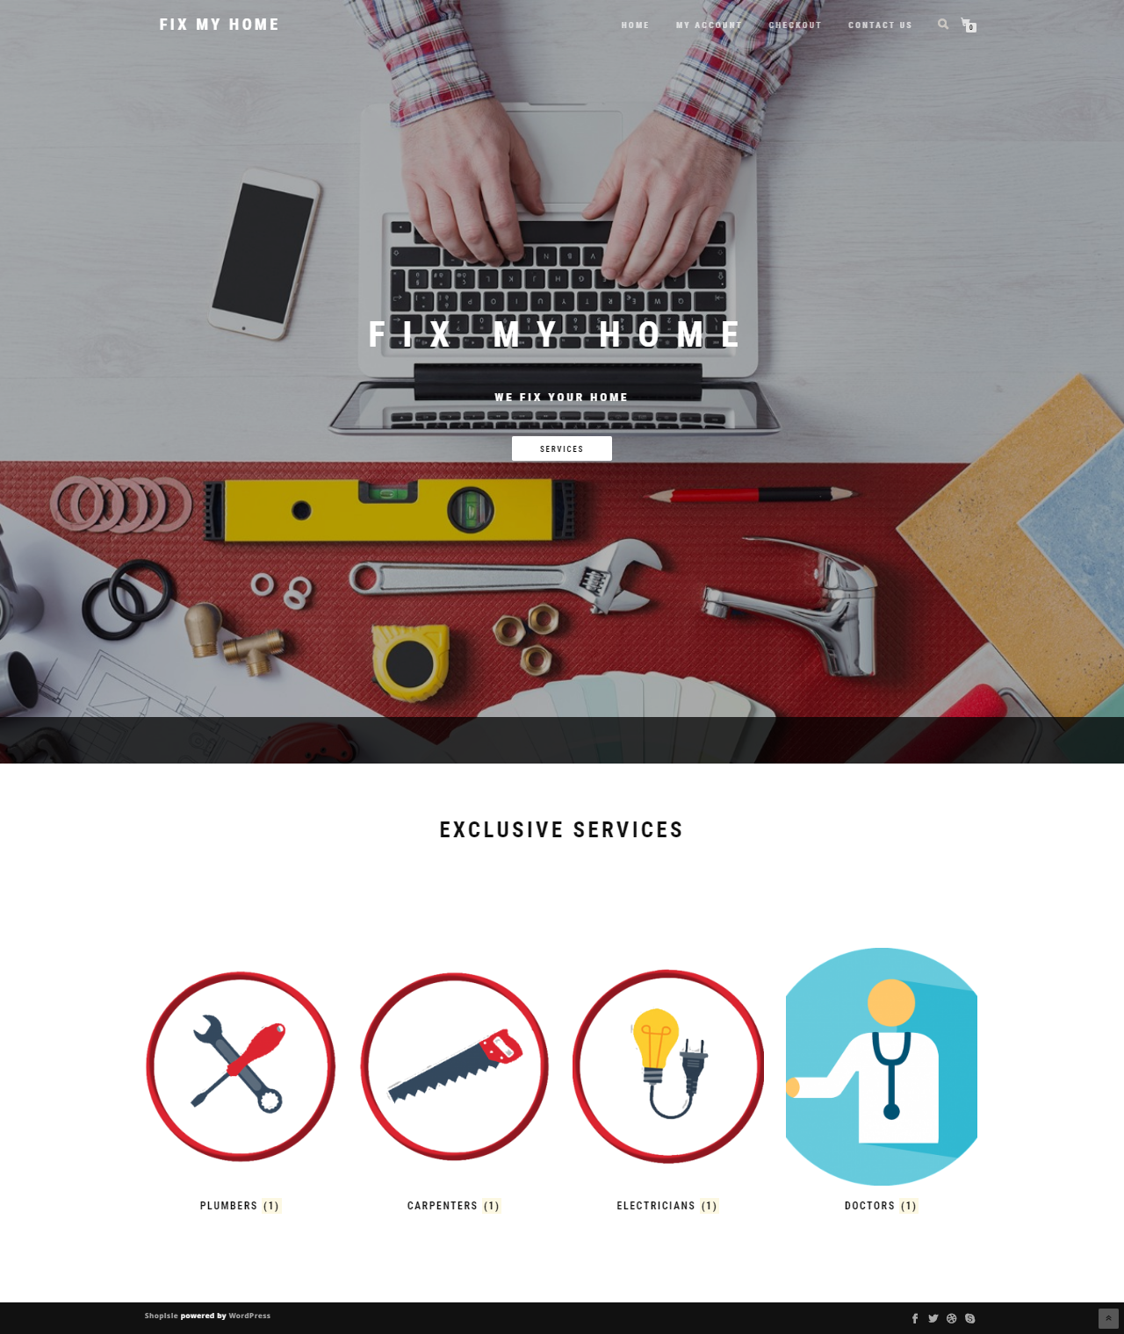

**Description:** This is the main page for the website, here you can check for available categories of services.

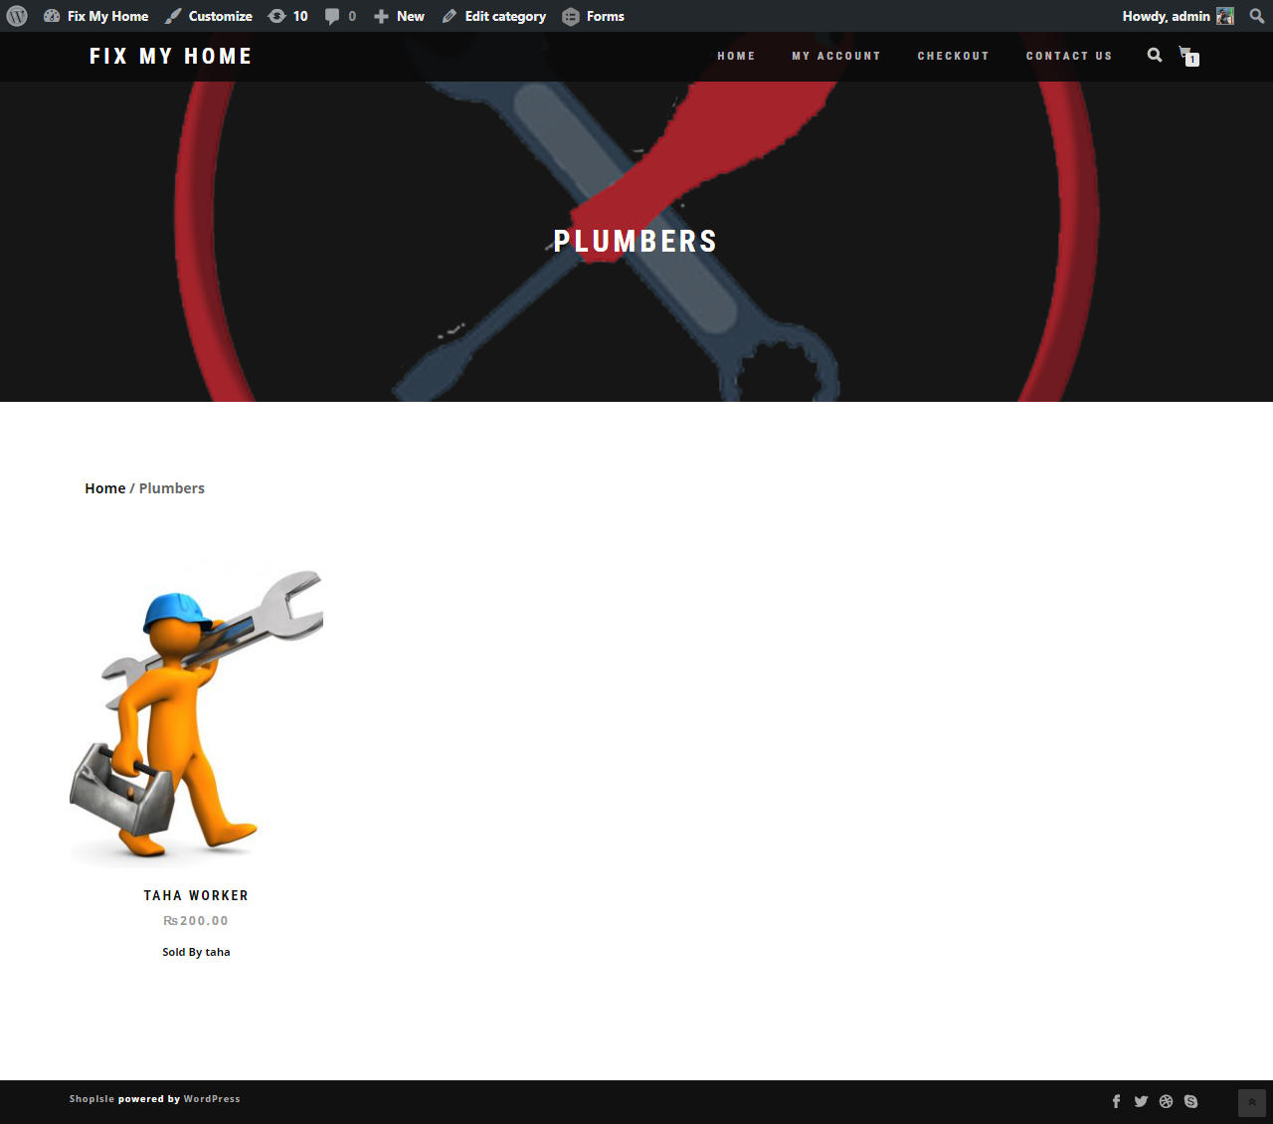

**Description:** After selecting a category from the services you can select a service available worker in that category.

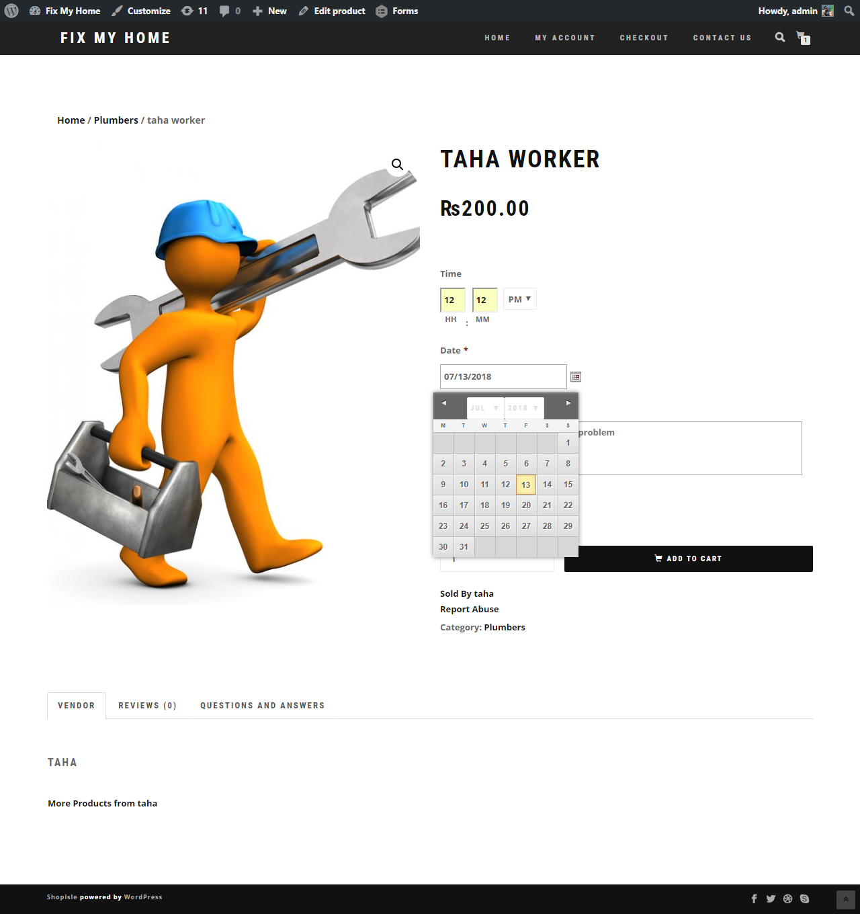

**Description:** After selection a worker you can select a time and date at of your choosing, at which you want to the worker to come at your home. Also you will send a detailed description telling about the problem in your house.

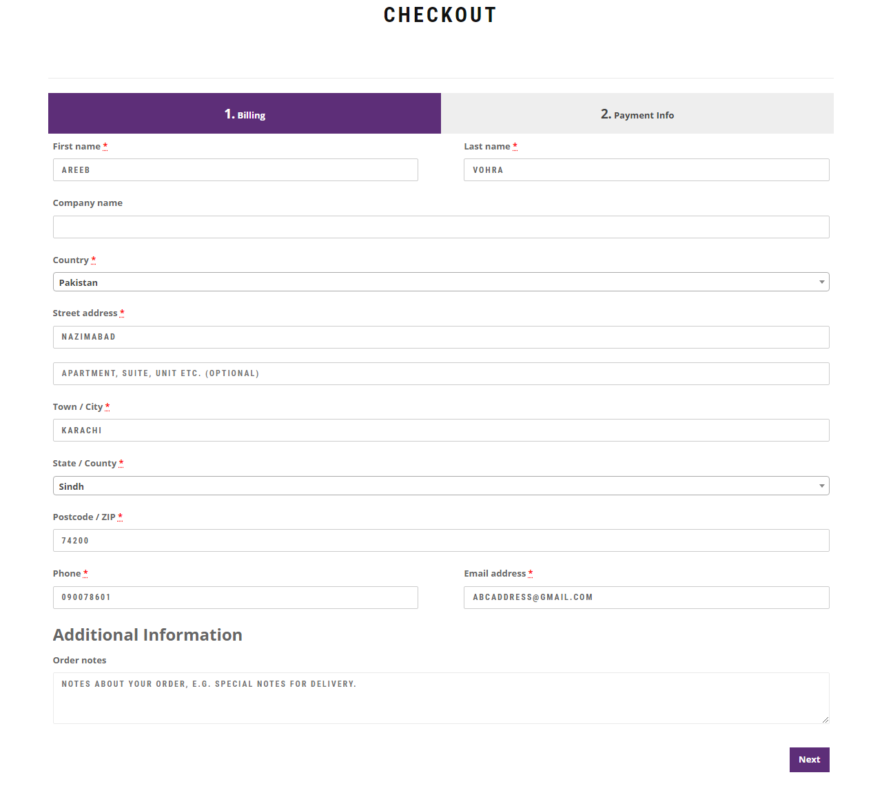

**Description:** after selection of worker you will proceed to the checkout page where you will enter your contact details.

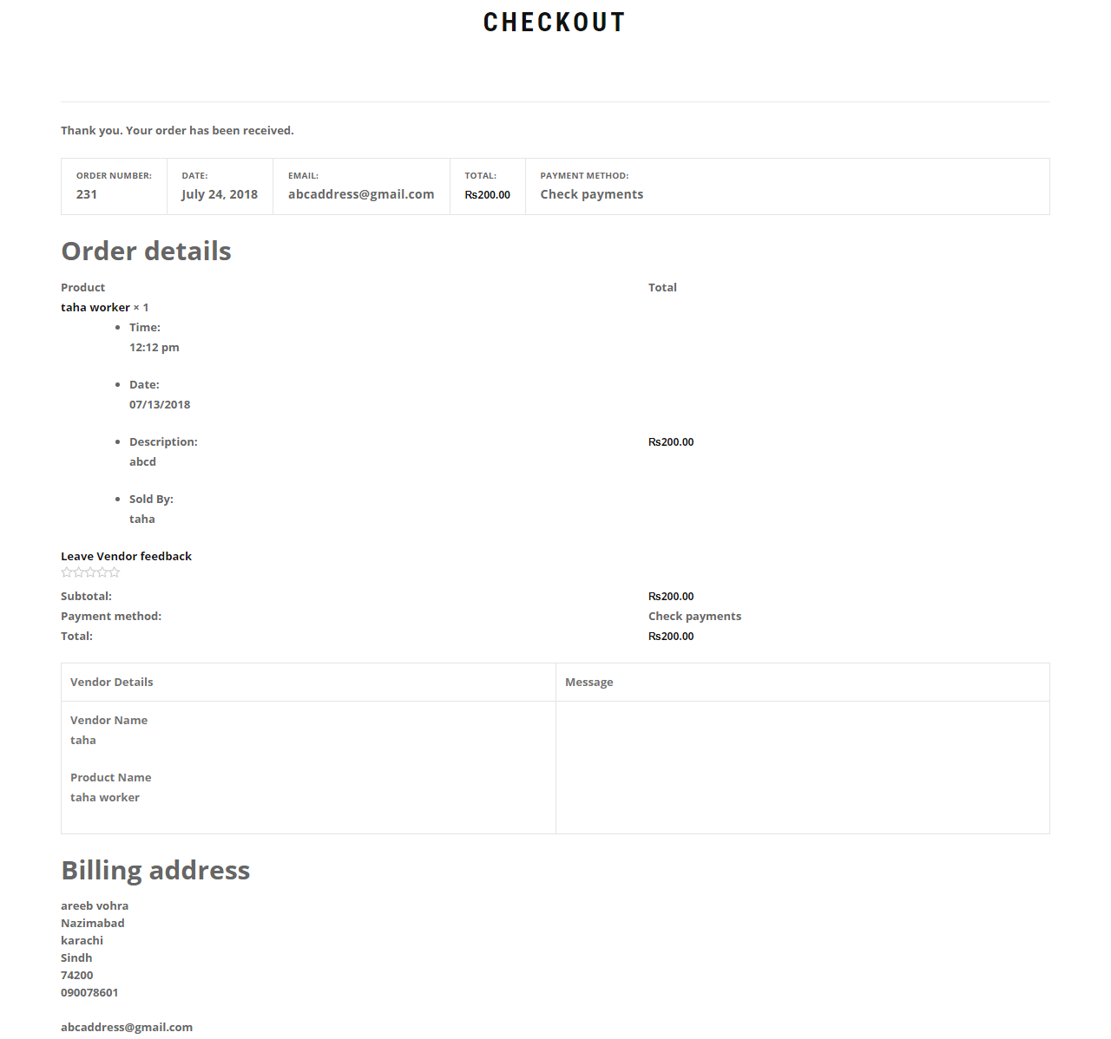

**Description:** After submitting your contact details you will get a summary of your order.

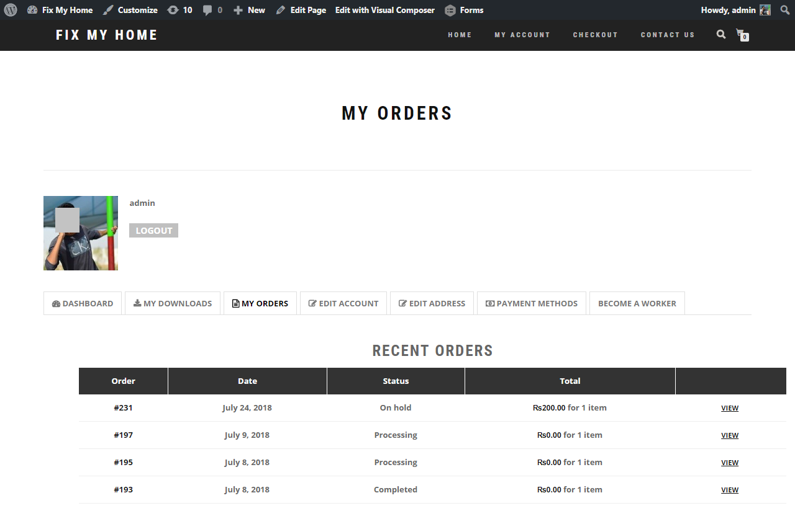

**Description:** You can check your order status and previous orders in the MY ACCOUNT 🡪 MY ORDERS section.

## C:\Users\Abdul\Desktop\web shots\admin all users.png4.4 Admin Dashboard GUI

**Description:** Here is the Admin Dashboard where the admin can view all the Users and their roles connected to the site weather customers or workers.

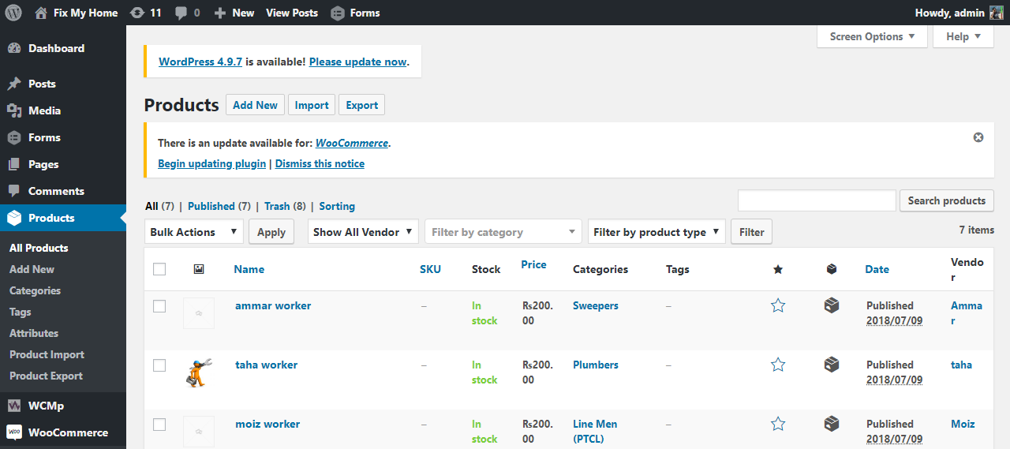

**Description:** Here the admin the view all the current workers active on the site.

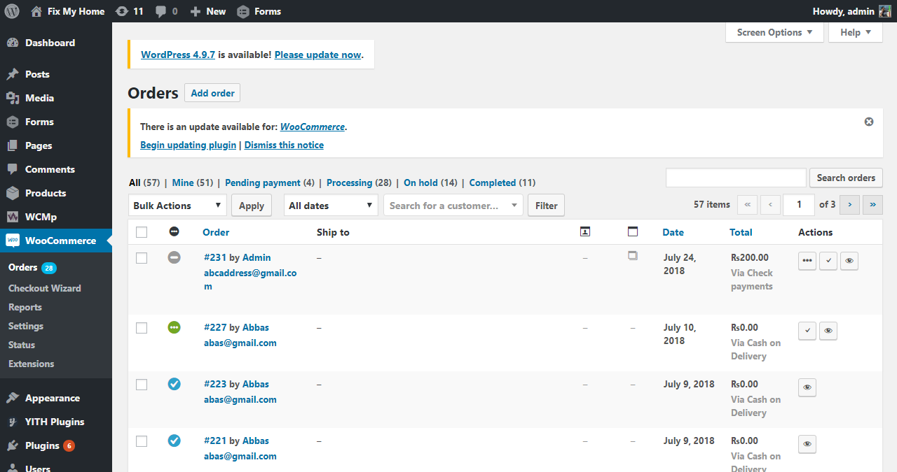

**Description:** Here the admin can view all the orders and check their status and modify them.

## 4.5 Android Application GUI (for customers)

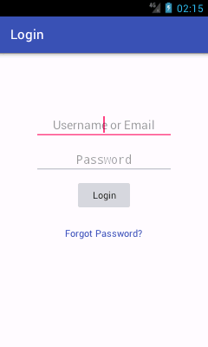 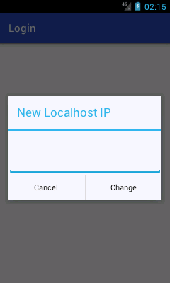

**Description:** Here the user will login to his/her account. Since the project is currently running on localhost the user has to enter his router IP for the application to connect with the localhost server, the IP section will not be necessary when the project is on a live domain.

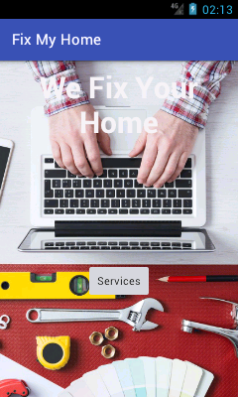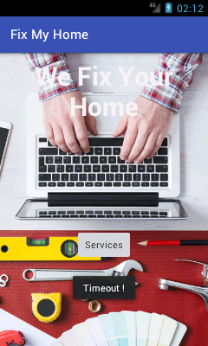

**Description:** After login here is the main view of the mobile application for the customers. The user can click the services button to check for available services.

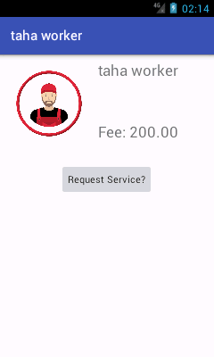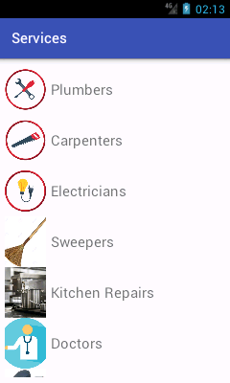

**Description:** on the left screen the user can view all the available service. On the right screen the user can view an individual worker and request for his service.

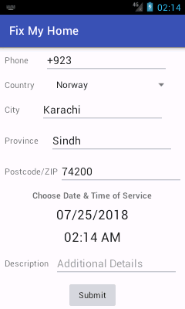 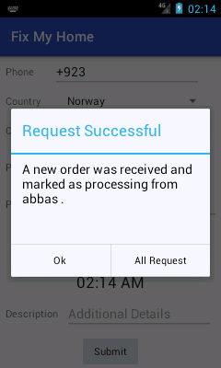

**Description:** Here the user will enter his contact details and the user can also select date and time on which he would like worker to come at the house, uthe user will also enter description about the problem he would to fix.

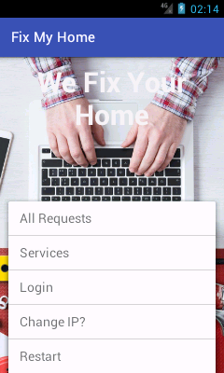 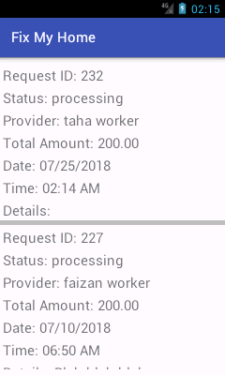

**Description:** Here the user can open the menu and he/she can view his order in the All Requests section. The user can also view previous order.

## 4.6 Mobile Application GUI (for Workers)

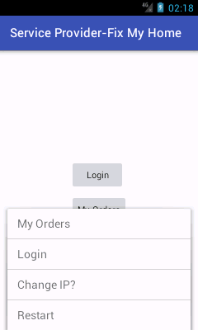 

**Description:** Here is the login screen and welcome screen for the worker. The worker first has to login to his account so that he can view his orders and requests.

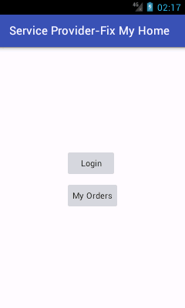 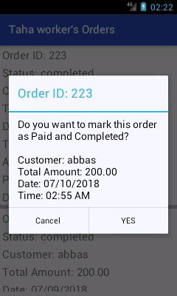

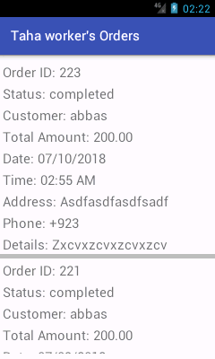

**Description:** After login the worker check his orders received. He can also change status of his order from pending to complete